|  |  |  |  |
| --- | --- | --- | --- |
| 1 | | 54,190 | |
| **NUMERO DE FRONTERAS** | | **ENERGIA AGREGADA** | |
|  | | | |
| 199,416,232 | 137 | | 7,371,830 |
| INGRESO 2019 | DÍAS CERTIFICADOS 2019 | | ENERGIA RESPALDADA 2019 |
|  | | | |
| 161,823,679 | 134 | | 5,972,257 |
| INGRESO 2020 | DÍAS CERTIFICADOS 2020 | | ENERGIA RESPALDADA 2020 |
|  | | | |
| 140,734,500 | 157 | | 6,192,887 |
| INGRESO 2021 | DÍAS CERTIFICADOS 2021 | | ENERGIA RESPALDADA 2021 |

**HISTORICO REINTEGRO DDV**

|  |  |  |  |
| --- | --- | --- | --- |
|  | **2019** | **2020** | **2021** |
| **ENE** | - | 33.52 | 18.69 |
| **FEB** | - | 12.71 | 28.9 |
| **MAR** | - | 50.26 | 4.23 |
| **ABR** | - | - | 2.08 |
| **MAY** | 7.1 | 9.01 | 20.08 |
| **JUN** | 27.09 | 18.7 | 14.02 |
| **JUL** | 33.48 | 11.61 | 16.27 |
| **AGO** | 20.35 | 5.83 | 11.3 |
| **SEP** | 17.03 | - | 14.96 |
| **OCT** | 25.17 | - | 10.19 |
| **NOV** | 47.2 | - | - |
| **DIC** | 22.0 | 20.18 | - |

**Los valores de la tabla están en millones de COP**

**REINTEGRO MECANISMO DDV OCTUBRE 2021**

|  |  |  |  |  |  |
| --- | --- | --- | --- | --- | --- |
| FECHA | TIPO DIA | CANTIDADES RESPALDO | PRECIO PONDERADO USD | TRM | PNETO |
| 2021-10-06 | Miércoles | 35,895 | 5.98 | 3,784.44 | 727,855 |
| 2021-10-07 | Jueves | 35,895 | 5.98 | 3,784.44 | 727,855 |
| 2021-10-08 | Viernes | 35,901 | 5.98 | 3,784.44 | 727,977 |
| 2021-10-19 | Martes | 35,901 | 5.98 | 3,784.44 | 727,977 |
| 2021-10-20 | Miércoles | 35,901 | 5.98 | 3,784.44 | 727,977 |
| 2021-10-21 | Jueves | 35,901 | 5.98 | 3,784.44 | 727,977 |
| 2021-10-22 | Viernes | 35,901 | 5.98 | 3,784.44 | 727,977 |
| 2021-10-25 | Lunes | 35,901 | 5.98 | 3,784.44 | 727,977 |
| 2021-10-26 | Martes | 35,901 | 5.98 | 3,784.44 | 727,977 |
| 2021-10-27 | Miércoles | 35,901 | 5.98 | 3,784.44 | 727,977 |
| 2021-10-28 | Jueves | 35,901 | 5.98 | 3,784.44 | 727,977 |
| 2021-10-29 | Viernes | 35,901 | 5.98 | 3,784.44 | 727,977 |
| 2021-10-30 | Sábado | 35,901 | 5.98 | 3,784.44 | 727,977 |
| 2021-10-31 | Domingo - Festivo | 35,901 | 5.98 | 3,784.44 | 727,977 |

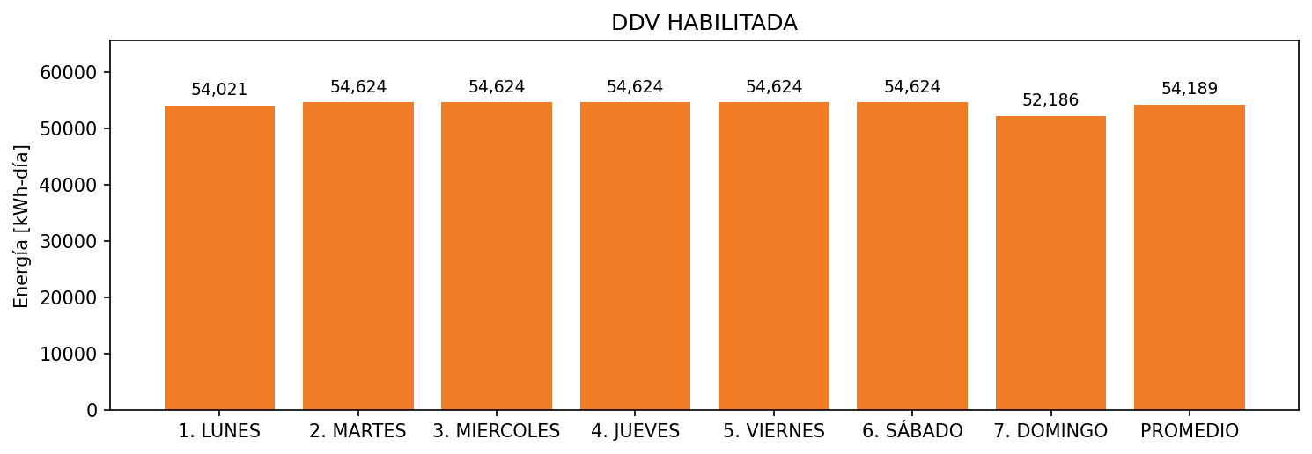

|  |  |  |  |  |  |  |  |  |  |
| --- | --- | --- | --- | --- | --- | --- | --- | --- | --- |
| **FRONTERA** | **COD SIC** | **FRT DDV** | **TIPO DDV** | **PROMEDIO** | **PRÓXIMA ACTUALIZACIÓN** | **MARGEN DE ERROR** | **ÚLTIMA PRUEBA DDV** | **DÍAS PARTICIPACIÓN** | **FECHA REFERENCIA PRÓXIMA PRUEBA DDV** |
| CENTRO COMERCIAL VIVA BARRANQUILLA | Frt31139 | Frt32657 | LBC | 54,189 | 2021-12-01 | 2,5 | 2021-11-02 | 0.0 | 2022-03-14 |